**Environmental Impact of Electronic Vehicles (EVs)**

Over the last decade, there’s been an increase in the purchasing of electric vehicles (EV). There are [many reasons](https://www.energysage.com/electric-vehicles/advantages-of-evs/) why one might consider making the switch to an EV – electric cars are higher efficiency than gas-powered cars, can reduce your dependence on fossil fuels and require less maintenance than most cars, to name three popular reasons.

One draw for many people who decide to buy an electric car is that EVs are often considered to be one of the most sustainable forms of transportation. Unlike hybrid vehicles or gas-powered cars, EVs run solely on electric power – depending on how that electric power is produced, your EV can be run 100% on sustainable, renewable resources. There are four factors to consider when evaluating the impact of electric cars on the environment: tailpipe emissions, well-to-wheel emissions, the energy source that charges the battery, and the car’s efficiency.

When taking well-to-wheel emissions into account, all-electric vehicles emit an average of around [4,450 pounds](https://afdc.energy.gov/vehicles/electric_emissions.html) of CO2 equivalent each year. By comparison, conventional gasoline cars will emit over twice as much annually. The amount of well-to-wheel emissions your EV is responsible for is largely dependent on your geographic area and the energy sources most commonly used for electricity.  For example, if you live in California, your electricity likely comes from natural gas. This doesn’t hold true if your electric vehicle is being used and charged in New Hampshire, as the state sources most of it's electricity from nuclear power plants.

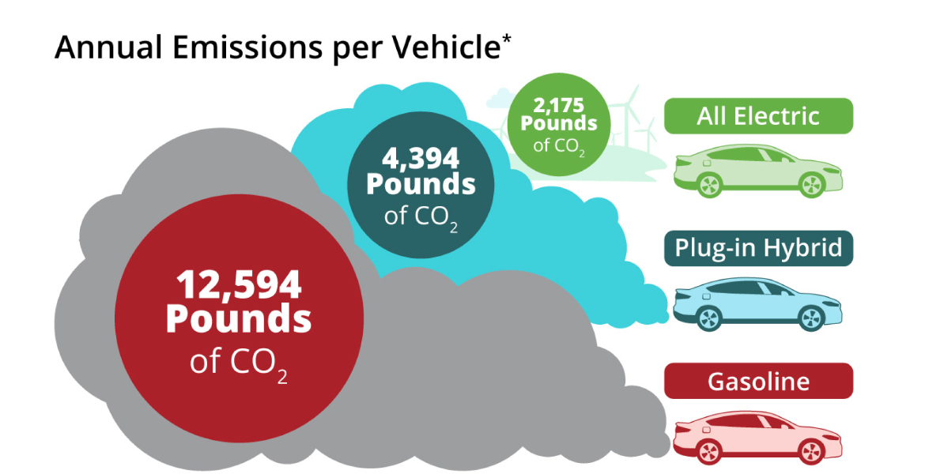

Natural gas provides the majority of electricity in the United States, followed closely by coal. It is often considered to be the “cleanest” fossil fuel, because it emits 50 to 60 percent lesscarbon dioxide than coal. Coal is responsible for around 65 percent of carbon dioxide emissions by the electric power sector in the U.S. That being said, even if your electricity is primarily from a coal plant, driving an EV will likely still overall have lower or similar well-to-wheel emissions when compared to a conventional car. In most places in the United States today, the mix of resources used to generate your electricity mean that driving an electric vehicle will produce lower well-to-wheel emissions than a traditional car.

**Palo Alto, California – As a case study**

Transportation is the single largest GHG emissions generator in California, representing over one-third of total GHG emissions, Electric Vehicles play an integral role in helping California meet the CSNA emissions reduction goal.

The City of Palo Alto encourages the use of Electric Vehicles (EVs) and indeed has one of the highest adoption rates of electric vehicles (EVs) in California and the country at large. The city ranks as one of the top in the nation to embrace this clean technology. According to reports, 1 in 5 households drive an Electric Vehicle (EV). These vehicle type now account for more than 30% of new car sales in Palo Alto. The city encourages the use of Electric Vehicles (EVs) as part of our progress towards becoming one of the greenest cities in the country.

EVs are overall more environmentally friendly than traditional vehicles. That’s because when you drive an EV, you reduce the amount of emissions—and noise pollution—you add to the environment.

Even though some of that electricity comes from fuel burning power plants, emissions are still reduced, since the production of electricity is more efficient than gasoline engines. As California progresses with implementation of renewable energy, the electricity produced in the state will produce fewer emissions which are overall more environmentally friendly than traditional vehicles. That’s because when you drive an EV, you reduce the amount of emissions and noise pollution you add to the environment.